**APPROVED**

The Logic Luminaries Enterprise

Software QA department manager

John Doe

**REVIEWED**

The Logic Luminaries Enterprise

Software Development manager

Tretta Gumberg

**SOFTWARE QUALITY ASSURANCE BUG REPORTING PROCESS**

The purpose of this document is to ensure quality of the end product of the company by the following process of creating bug reports for any of the company software.

Ensure all the reports and associated data (attachments, screenshots, source videos) are uploaded and stored only on the company’s [JIRA](https://JIRA.com/) and/or company’s localhost server.

In any case of access issues with accessing the company [JIRA](https://JIRA.com/), contact your team lead or create a helpdesk ticket at [HELPME](mailto:help@me.com?subject=NOTHING%20WORKS,%20I%20CANT%20WORK,%20DO%20SOMETHING!!1) portal.

Prior to commencing any testing activities make sure to get acquainted with the current document and all the accompanying documentations stored at the dedicated [SharePoint.](https://Sharepoint.com/)

For creation of a bug report, the tester shall follow these steps:

1. Access the allocated project in the JIRA.

* Open your preferred web browser and navigate to the JIRA website.
* Log in to your JIRA account using your credentials.
* Once logged in, you'll be directed to the dashboard.
* Locate the project you've been allocated to by either browsing through the list of projects or using the search functionality.
* Click on the allocated project to enter its workspace.

1. Find the bug report template created by your lead tester.

* Within the allocated project's workspace, navigate to the issue types or templates section. This can usually be found in the sidebar menu or under project settings.
* Look for a template specifically labeled as a bug report template. If your lead tester has created a template, they may have named it accordingly (e.g., "Bug Report Template - [Project Name]").
* If the template is not readily visible, you can search for it using the search bar or consult with your lead tester or project administrator for guidance.

1. Create a new report based on the template.

* Once you've located the bug report template, click on it to open the template.
* Review the fields and sections included in the template. Your lead tester may have predefined fields for information such as summary, description, steps to reproduce, expected behavior, actual behavior, environment details, etc.
* Click on the option to create a new issue based on the template. This may be labeled as "Create Issue," "Create Bug," or similar, depending on your JIRA configuration.
* Fill in the required information in the respective fields based on the guidelines provided in the template. Provide as much detail as possible to ensure clarity and ease of understanding for the development team.

1. Ensure the topic of the report contains the following information.

* Project name
* Issue type
* Issue location
* Severity
* Runtime error code (if applicable)
* In the beginning of the topic put [TO VET] status

1. In the upper paragraph of the bug report make a brief explanation of the issue

* Begin the bug report with a concise summary or explanation of the issue at hand. This summary should provide a high-level overview of the problem without going into too much detail.
* Include information such as the nature of the issue, its impact on the software or system, and any relevant context that helps the reader understand the significance of the problem.
* Keep this explanation brief but informative to provide a clear introduction to the bug.

1. Follow by making and ordered list of the steps to reproduce.

* After the introductory paragraph, create an ordered list outlining the steps necessary to reproduce the issue.
* Start with the initial conditions or prerequisites required for reproducing the bug.
* Then list each step, in sequential order, that leads to the manifestation of the issue.
* Be precise and specific in describing each step to ensure accurate reproduction of the problem by the development team.

1. Explain why the given issue is a problem.

* Following the steps to reproduce, provide an explanation of why the identified issue is problematic or undesirable.
* Discuss the potential impact of the issue on users, functionality, performance, security, etc.
* Highlight any potential risks or consequences associated with the unresolved issue to emphasize its significance to the development team.

1. Describe the expected way the software should operate after resolving the issue.

* After explaining the problem, describe the expected behavior of the software once the issue has been resolved.
* Clearly articulate the desired outcome or functionality that should be achieved post-resolution.
* This description helps align the understanding of the expected fix and ensures that the development team knows what success looks like.

1. (Optional) Suggest ways of resolving the issue

* Optionally, provide suggestions or ideas for resolving the reported issue.
* Offer insights, recommendations, or potential solutions based on your understanding of the problem and its underlying causes.
* While optional, providing suggestions can sometimes expedite the resolution process by offering additional context or guidance to the development team.

10) Attach any associated files (data tables, crush reports, screenshots)

* If there are any associated files that provide additional information or evidence related to the bug, attach them to the bug report.
* This could include data tables, crash reports, screenshots illustrating the problem, or screen capture videos demonstrating the issue in action.
* Attaching relevant files helps provide comprehensive context and aids in the investigation and resolution of the bug.

11) After submitting the report, re-enter it by clicking edit, and select the severity in accordance with the provided severity list on [SharePoint.](https://Sharepoint.com/)

* After submitting the bug report, revisit it by clicking the "Edit" button to make any necessary adjustments or additions.
* Select the appropriate severity level for the reported issue based on the severity list provided on SharePoint or any other designated platform.
* Ensure that the selected severity accurately reflects the impact and urgency of the bug to facilitate proper prioritization by the development team.

12) Assign this report to your team lead, so this report could be vetted

* Assign the bug report to your team lead or another designated authority for review and vetting.
* This step ensures that the bug report undergoes a quality check and validation process before further action is taken.
* Your team lead may provide feedback, clarification, or additional instructions based on the reviewed bug report.

13) Copy the report link and brief descriptions to the separate tracking list

* Copy the link to the bug report and any brief descriptions or summaries to a separate tracking list or document.
* This tracking list helps maintain a centralized record of reported bugs, their status, and any relevant details for easy reference and monitoring.
* Updating the tracking list ensures transparency and accountability in managing reported issues within the project.

The team leads shall vet all the reports and reassign them to the development team lead with a [VETTED] status.

The development team lead distributes the reports to the developers for resolving, or, in case of lack or unclear information creates a new testing case for the testing team.

All the [RESOLVED] reports shall be regressed in order.

Testing is deemed as ongoing, until there are any tickets with no [CLOSED] status.

Accountability matrix:

|  |  |
| --- | --- |
| Creation of bug reports | Tester |
| Reports vetting | Testing lead |
| Submission of reports to the dev team | Testing lead |
| Bug resolution | Development team software engineer |
| Confirmation testing (Regression) | Tester |
| Closing the report | Dev team lead |

Sample of a ‘good’ ticket:

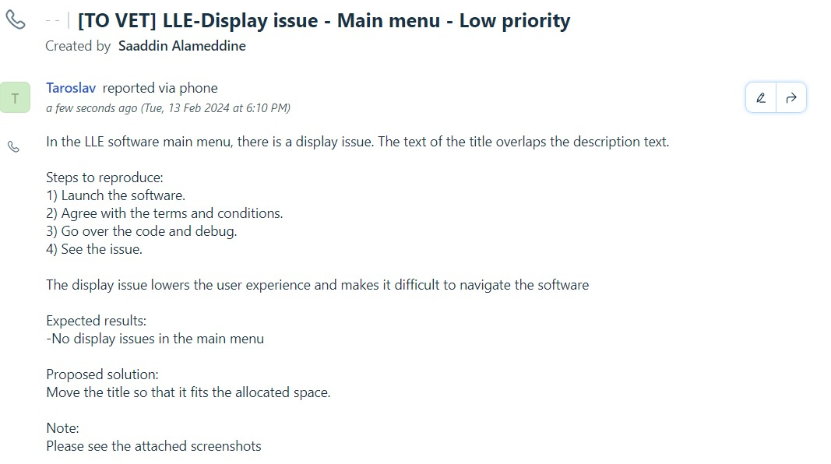

Revision History:

|  |  |  |  |
| --- | --- | --- | --- |
| Date | Revision Description | Version | Author |
| 2024-02-12 | Initial creation of the document. | 1.0 | John Doe |
| 2024-02-15 | Updated roles and responsibilities in the accountability matrix | 1.1 | Jane Smith |
| 2024-02-20 | Added contact information for team members. | 1.2 | Emily Johnson |

**Quality Assurance Testing Team Lead Adam Smith**